API Security analysis report

Cyber Security Internship Task 3
Future Interns
Repository: FUTURE_CS_03
Prepared by: Delina Million Teshome
Date: August 2026

API Security Risk Analysis Report

JSONPlaceholder Test API
Prepared for: Future Interns — Cyber Security Task 3
Assessment Type: Read-Only API Security Risk Analysis
Testing Tool: Postman
Assessment Date: September 2, 2026
API Tested: JSONPlaceholder
Base URL: https://jsonplaceholder.typicode.com

1. Executive Summary
This report presents a read-only security risk analysis of the JSONPlaceholder public test API. The assessment was performed using Postman and focused on identifying common API security risks without exploiting vulnerabilities or attempting to bypass security controls.
Four GET endpoints were reviewed:
- /posts
- /users
- /comments
- /todos
The assessment examined authentication requirements, HTTP response headers, response data, rate-limiting information, and potential information exposure.
The analysis identified several Low-severity risks and informational observations, primarily related to unauthenticated access to publicly available API resources and disclosure of implementation information through the X-Powered-By response header.
The API also demonstrated positive security characteristics, including the presence of rate-limit headers and the X-Content-Type-Options: nosniff security header.
Because JSONPlaceholder is intentionally designed as a public testing and learning API and its data is fictional, the findings should not be interpreted as evidence of a real-world data breach. Instead, they demonstrate security risks that would become more significant if similar configurations were used by a production API handling private or sensitive information.

2. Objective
The objective of this assessment was to:
- Analyze a public/demo API using safe, read-only requests.
- Review the API's documentation.
- Test selected API endpoints using Postman.
- Determine whether authentication is required.
- Inspect HTTP response headers.
- Review the type and amount of information returned by API responses.
- Identify potential API security risks.
- Assign an appropriate severity level to identified risks.
- Explain potential business impact in simple terms.
- Recommend practical remediation measures.
The assessment was conducted as a security analysis rather than an exploitation exercise.

3. Scope and Ethical Considerations

3.1 Scope
The assessment was limited to the publicly available JSONPlaceholder test API.
Base URL:
https://jsonplaceholder.typicode.com
The following read-only GET endpoints were tested:
Endpoint | Method | Purpose
/posts | GET | Retrieve post records
/users | GET | Retrieve user records
/comments | GET | Retrieve comment records
/todos | GET | Retrieve task/to-do records

3.2 Ethical Restrictions
The assessment followed a read-only methodology.
The following activities were not performed:
- Authentication bypass attempts
- Authorization bypass attempts
- Exploitation of vulnerabilities
- Denial-of-service or flooding tests
- Brute-force attacks
- Destructive requests
- Testing of private systems
- Attempts to access restricted resources
Only safe GET requests and passive inspection of responses were performed.

4. API Overview
JSONPlaceholder is a free fake REST API intended for testing and prototyping.
It provides resources such as:
- Posts
- Comments
- Albums
- Photos
- Todos
- Users
The API allows developers and security learners to practice making HTTP requests and working with JSON responses without interacting with a real production database.
For this assessment, the API was selected because it is explicitly intended for testing and learning.

5. Tools Used

Postman
Postman was used to:
- Send HTTP GET requests.
- Inspect HTTP status codes.
- Review authentication settings.
- Examine response headers.
- Analyze JSON response data.
- Observe rate-limiting information.

JSONPlaceholder Documentation
The official JSONPlaceholder documentation was reviewed to understand the available resources and endpoint structure before testing.

6. Methodology
The assessment followed these steps:

Step 1 — Documentation Review
The JSONPlaceholder documentation was reviewed to identify available resources and understand how the API should be accessed.

Step 2 — Postman Configuration
Postman was configured to send GET requests to the JSONPlaceholder base URL.
No authentication credentials or tokens were configured.

Step 3 — Endpoint Testing
The following endpoints were tested:
- GET /posts
- GET /users
- GET /comments
- GET /todos

Step 4 — Authentication Inspection
The Postman Authorization setting was inspected.
The tested endpoints were accessible using No Auth.

Step 5 — Header Inspection
HTTP response headers were reviewed for:
- Security controls
- Technology disclosure
- Rate limiting
- Caching
- Content handling
- CORS-related information

Step 6 — Response Inspection
The returned JSON data was reviewed to determine what information was exposed by each endpoint.

Step 7 — Risk Classification
Potential security concerns were classified as:
- High
- Medium
- Low
- Informational
Severity was assigned based on the observed configuration and the context of JSONPlaceholder as a demo API.

7. Endpoint Testing Results

7.1 GET /posts
Request:
GET https://jsonplaceholder.typicode.com/posts
Authentication: No Auth
Result: 200 OK
The endpoint successfully returned JSON post records containing fields including:
- userId
- id
- title
- body

Observation
The endpoint is publicly accessible without authentication.
That's expected for a public test API, but the same setup on a production endpoint would let anyone who found the URL pull data without logging in.
Risk: Low
Evidence: See Screenshot 1.
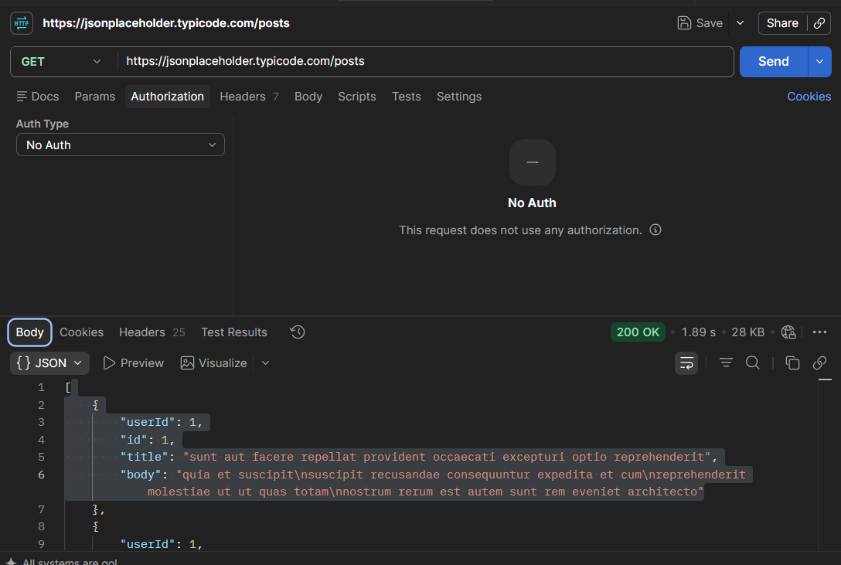

7.2 GET /users
Request:
GET https://jsonplaceholder.typicode.com/users
Authentication: No Auth
Result: 200 OK
The response included user profile-style information such as:
- Name
- Username
- Email address
- Address
- Geographic coordinates
- Phone number
- Website
- Company information

Observation
The endpoint provides a relatively large amount of user-related information without requiring authentication.
The records are fictional, so nothing was actually exposed here. A real API returning this much personal data without authorization would be a different story.
Risk: Low in the JSONPlaceholder context
Potential production impact: Medium or higher depending on the sensitivity and quantity of real data exposed.
Evidence: See Screenshot 2.
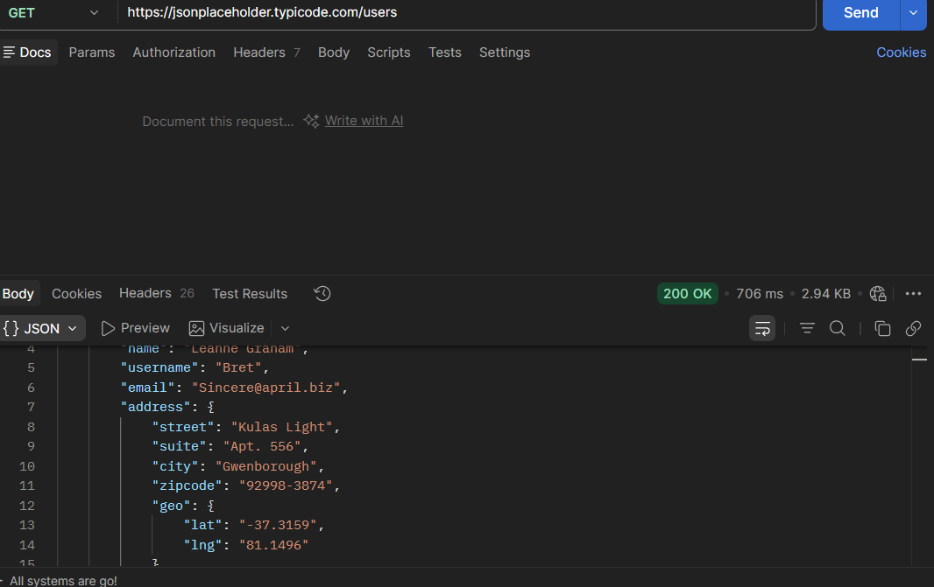

7.3 GET /comments
Request:
GET https://jsonplaceholder.typicode.com/comments
Authentication: No Auth
Result: 200 OK
The response contained fields including:
- postId
- id
- name
- email
- body

Observation
The API returns email-style contact information together with comment data without requiring authentication.
As with the other endpoints, these records aren't real, so this is logged as a low-risk observation rather than a confirmed breach.
In a production environment, publicly exposing user email addresses could enable unwanted contact, data harvesting, phishing, or privacy violations.
Risk: Low
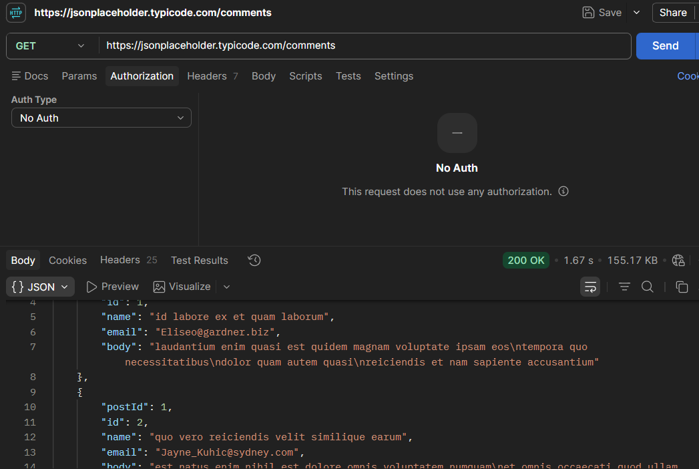

7.4 GET /todos
Request:
GET https://jsonplaceholder.typicode.com/todos
Authentication: No Auth
Result: 200 OK
The endpoint returned task information including:
- userId
- id
- title
- completed

Observation
The endpoint is accessible without authentication.
The returned information does not appear particularly sensitive in the context of this demo API.
Therefore, this endpoint was treated primarily as an observation rather than a significant vulnerability.
Risk: Informational / Low
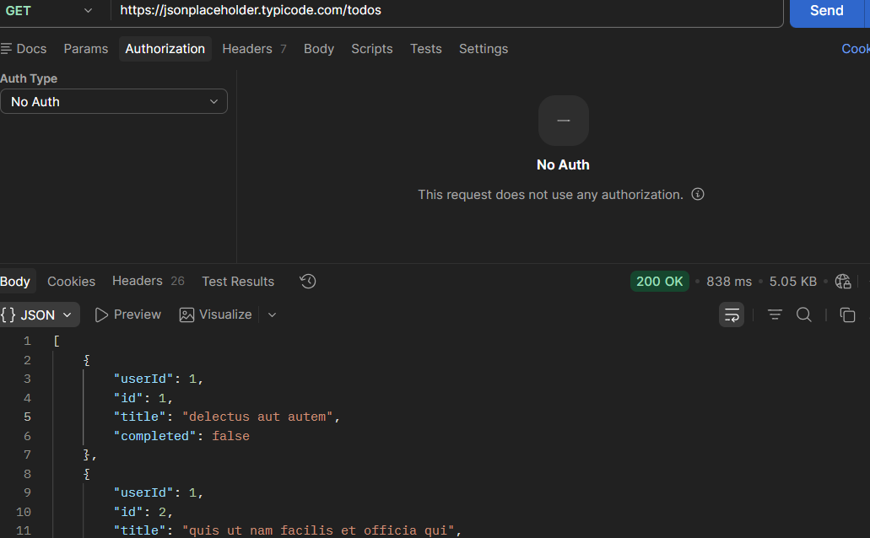

8. Security Findings

Finding 1 — Unauthenticated Access to API Resources
Severity: Low

Description
The tested GET endpoints were accessible without authentication.
Postman was configured with No Auth, and the requests returned successful 200 OK responses.

Security Risk
For a production API, publicly accessible endpoints may allow unauthorized users to retrieve information that should only be available to authenticated users.

Business Impact
If sensitive production data were exposed through unauthenticated endpoints, potential impacts could include:
- Unauthorized data access
- Privacy violations
- Information harvesting
- Regulatory or compliance concerns
- Loss of customer trust

JSONPlaceholder Context
Since JSONPlaceholder is built to be publicly accessible, open GET access here isn't a serious issue on its own — it's the expected behavior of the platform.

Recommendation
For production APIs:
- Require authentication for protected resources.
- Use secure authentication mechanisms such as OAuth 2.0 or appropriately designed API tokens.
- Apply authorization checks to every protected resource.
- Ensure public endpoints only return intentionally public information.

Finding 2 — Exposure of User and Contact-Style Data
Severity: Low

Description
The /users and /comments endpoints return fields such as names, usernames, email addresses, phone numbers, addresses, and other profile-style information.

Security Risk
If equivalent information were returned by a real production API without proper authorization or data minimization, users could potentially collect personal information at scale.

Business Impact
Potential business consequences could include:
- Privacy incidents
- Customer complaints
- Phishing opportunities
- Data harvesting
- Reputational damage
- Regulatory consequences

Recommendation
Production APIs should:
- Return only the fields required by the client.
- Apply authorization checks before returning user information.
- Avoid exposing unnecessary personal information.
- Use data minimization principles.
- Review API responses for sensitive information before deployment.

Finding 3 — Technology Disclosure Through X-Powered-By
Severity: Low

Description
The response headers included:
X-Powered-By: Express
This reveals that the API uses the Express framework.

Security Risk
Technology disclosure can assist attackers with fingerprinting and reconnaissance by revealing implementation details about a system.
The header itself does not provide unauthorized access or prove that the application is vulnerable.

Business Impact
In a production environment, unnecessary technology disclosure can provide attackers with additional information during reconnaissance.

Recommendation
Production applications should consider disabling unnecessary framework-identification headers.
For Express applications, the X-Powered-By header can be disabled through appropriate application configuration.

Finding 4 — CORS Configuration Observation
Severity: Informational

Observation
The response included:
Access-Control-Allow-Credentials: true
However, an Access-Control-Allow-Origin header was not observed in the inspected response.

Assessment
This observation alone is insufficient to classify the API as having a CORS vulnerability.
CORS security depends on the complete browser-facing configuration, including which origins are permitted and how credentialed requests are handled.
No CORS bypass or exploitation was attempted.

Recommendation
For production APIs:
- Explicitly define trusted origins.
- Avoid unrestricted origins when credentials are permitted.
- Review credentialed cross-origin requests carefully.
- Test CORS behavior using approved security testing procedures.

9. Positive Security Controls
The assessment also identified several positive characteristics.

9.1 Rate-Limiting Information
The response included:
X-RateLimit-Limit: 1000
and:
X-RateLimit-Remaining: 999
This indicates that rate-limit information is being provided.

Security Benefit
Rate limiting can help reduce:
- Excessive automated requests
- Resource abuse
- Certain forms of automated data harvesting
- Denial-of-service risk
This was recorded as a positive security control, not a vulnerability.

9.2 X-Content-Type-Options
The API returned:
X-Content-Type-Options: nosniff

Security Benefit
This header helps prevent browsers from MIME-type sniffing responses and is a useful security hardening measure.
This was considered a positive security control.

9.3 JSON Content Type
The API returned:
Content-Type: application/json; charset=utf-8
This clearly identifies the response format and is appropriate for a JSON REST API.

10. Risk Summary
ID | Finding | Severity
F-01 | Unauthenticated access to API resources | Low
F-02 | User/contact-style data exposure | Low
F-03 | Technology disclosure via X-Powered-By | Low
F-04 | CORS configuration observation | Informational

Overall Risk Assessment
Overall assessed risk: Low
The overall rating reflects the intentional design of JSONPlaceholder as a public testing API. The observations demonstrate security considerations that would require greater attention in a production SaaS environment handling real customer or business data.
No High-severity vulnerabilities were identified within the read-only assessment.

11. Business Impact
The findings demonstrate several areas that should be considered when designing production APIs.
If similar configurations existed in an API containing real customer information, the organization could face:

Data Exposure
Unauthorized users could retrieve information that should be restricted.

Privacy Risk
Excessive exposure of names, email addresses, phone numbers, addresses, or other personal information could result in privacy incidents.

Reconnaissance
Technology-disclosure headers could provide attackers with additional information about the underlying technology stack.

Abuse
Without appropriate rate limiting, automated clients could potentially make excessive requests or harvest data.
The actual impact depends on the sensitivity of the information, authentication architecture, authorization model, and business context.

12. Remediation Recommendations
For a production SaaS API, the following controls are recommended:

1. Implement Strong Authentication
Require authentication for all endpoints that expose private or sensitive information.

2. Enforce Authorization
Authentication alone is not sufficient. The API should verify that an authenticated user is authorized to access the requested resource.

3. Minimize Response Data
Return only the information required by the client.
Avoid unnecessarily exposing:
- Personal contact information
- Internal identifiers
- System information
- Unused metadata

4. Configure CORS Securely
Explicitly define trusted origins and carefully control credentialed cross-origin requests.

5. Apply Rate Limiting
Implement appropriate rate limits based on:
- User
- API key
- IP address
- Endpoint sensitivity

6. Reduce Technology Disclosure
Remove unnecessary framework-identification headers such as X-Powered-By where appropriate.

7. Maintain Security Headers
Continue using appropriate HTTP security headers, including X-Content-Type-Options: nosniff.

8. Monitor API Activity
Production APIs should log and monitor suspicious access patterns, authentication failures, excessive requests, and unusual data retrieval behavior.

13. Limitations
This assessment was intentionally limited to safe, read-only testing.
The following areas were not fully tested:
- Authentication bypass
- Authorization bypass
- Broken Object Level Authorization (BOLA)
- Input validation vulnerabilities
- Injection attacks
- POST/PUT/PATCH/DELETE security
- Token security
- Session management
- Denial-of-service resistance
- Server-side vulnerabilities
- Business-logic vulnerabilities
No exploitation was performed.
Therefore, the absence of High or Medium findings does not mean that the API is universally secure. It means that no such issues were identified within the defined testing scope.

14. Conclusion
A read-only security assessment of the JSONPlaceholder test API was successfully completed using Postman.
Four GET endpoints were tested and inspected for authentication requirements, HTTP headers, response data, and basic security controls.
The main observations were unauthenticated access to public resources, exposure of user/contact-style fields, and technology disclosure through the X-Powered-By header. These were classified as Low severity within the context of JSONPlaceholder because the API is intentionally public and uses fictional data.
The assessment also identified positive security controls, including rate-limit headers and the X-Content-Type-Options: nosniff security header.
The exercise demonstrates the importance of authentication, authorization, data minimization, secure CORS configuration, rate limiting, and security-focused response-header management when developing production APIs.
Overall, the assessment achieved its objective of identifying and communicating API security risks without exploiting or disrupting the target system.

Assessment Result
API: JSONPlaceholder
Testing Type: Read-only API security analysis
Tool: Postman
Endpoints Tested: 4
High Findings: 0
Medium Findings: 0
Low Findings: 3
Informational Findings: 1
Overall Risk: Low

